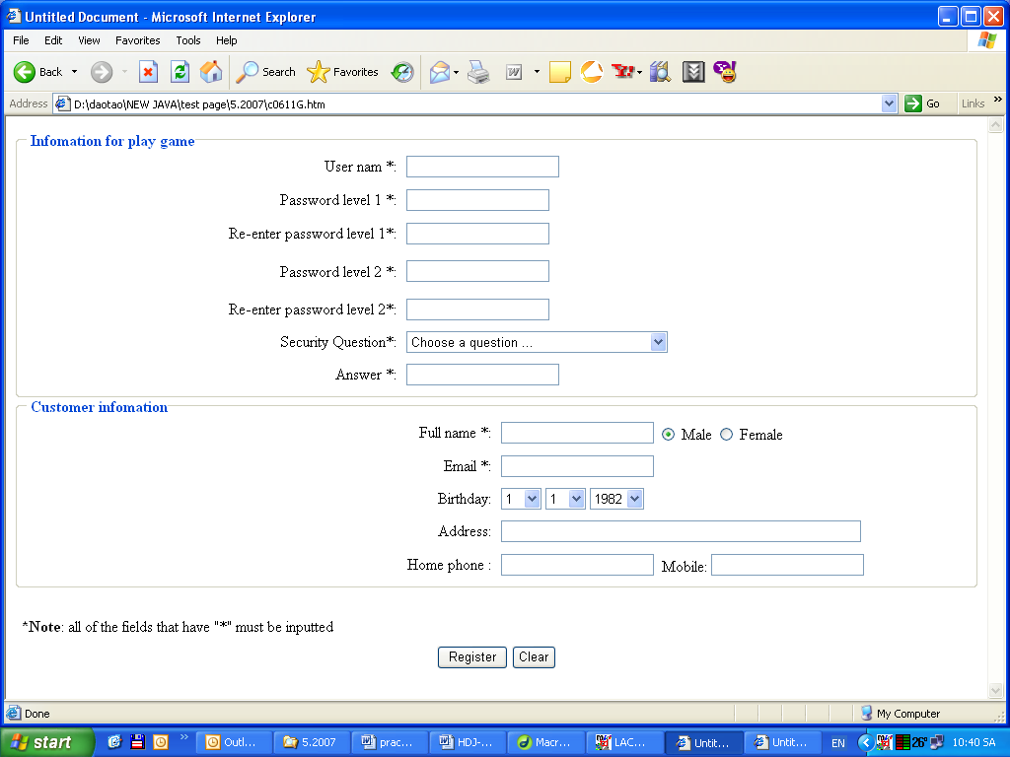
Figure 2
Data require (combo box) :
- Security Question:
  - Choose a question…
  - What is your library card number
  - What was your first phone number
  - What was your first teacher name
- Birthday : month-date – year
  - Month: 1-12
  - Date : 1-31
  - Year 1940 - 2000

- When user Click on Clear Button, all field must be cleared. [0.5]
- When user Click on Register Button, following validations will be performed : [7.5]
- All fields that have “*” in the label must be inputted (not empty). If one of them is empty, Message Box will display “your …. must be inputted” (… is field’s name)
- The length of userName and all password from 6 to 12 characters.
- Password level 1 and re-enter password level 1 is the same
- Password level 2 and re-enter password level 2 is the same
- Password level 1 and password level 2 must be differented
- Security Question must be choose
- Email must in correct format: userName@domainName (Example : aptech@sun.com.uk)

